Kisan Buddy: A Mobile Application for

Empowering Indian Farmers and Enhancing Agricultural Practices

1Vinay Gowda R, 2Devika N, 3Keerthana R,4Sushmitha NC, 5Sharmasth Vali Y

1234Student, 5Associate Professor

*Presidency School of Computer Science and Engineering Presidency University*

*Bangalore*

3[KEERTHANA.20211CIT0141@presidencyuniversity.in](mailto:KEERTHANA.20211CIT0141@presidencyuniversity.in) .5[sharmasth.vali@presidencyuniversity.in](mailto:sharmasth.vali@presidencyuniversity.in)

***Abstract:***

This paper gives out the mobile application that can be used by the farmers which would help them sell their produce at a reasonable price which is not possible due to lack of market access. The source of this problem is the absence of direct communication between the farmers and consumers. This mobile application which is being developed ensures that the produce from farmers are sold at fair prices, while consumers benefit from the quality products available at reasonable prices.In India, the traditional methods used by farmers are quite time-consuming and sedate.A expert system is put in order to predict the seasonal crops, generate the proper cost of produce that are sold by farmers and also farmers can buy or rent the artefacts required for their farming and can predict rain using weather forecasting and

can foresee the types of crops to be produced

at different seasons.Also application helps

in transportation, where farmers can call the drivers and book necessary vehicles by keeping in mind the cost and the amount of produce produced.This app by providing timely information about cost estimation for different farming tools and grains ultimately support farmers in making a wise decision and increase profitability.

***Keywords:*** Fertilizer, pesticides, farming tools, Android, smart farming, agritech solutions, crop management, farm productivity, agricultural analytics, weather forecasting, market prices, soil health monitoring, farm advisory services, fertilizer, pesticides, farming tools, Android, smart farming, agritech solutions, crop management, farm productivity, agricultural analytics, weather forecasting, market prices, soil health monitoring, and farm advisory services

# Introduction:

As discussed earlier, India is an agro-based country and, as a result, 60% of advancements that can be used to increase yields and trade their produce at better prices. The Kisan Buddy application addresses the limitations of traditional farming methods and existing applications by creating a user-friendly platform that assists farmers. Customers benefit

are expected to drive the market of Fertilizers Android app development. Fertilizer is an important aspect of agriculture and its development. As such, it's helpful to use an app on this important subject. The development of this app will promote the improvement of agricultural production. So to avoid this problem this application is very useful. Fertilizer schedule of each type of crop will get registered. Based on sowing date of crop, farmer will get reminders about application of fertilizer, herbicide as per schedule, pesticide for diseases and weather alerts if particular crop exceeds its favorable temperature range.Crop suggestion will

be given based on Soil type, geographical location. Farmer will get real time national level crop rates to get more benefit.

This software application is basically for sustainable development of farmers. Many times farmer is confused to take decisions regarding selection of fertilizer, pesticide and time to do particular farming actions. So to avoid this problem this application is very useful. Fertilizer schedule of each type of crop will get registered.

# Related work

The existing marketing and agricultural practices are perforated with insufficiencies that perforate both farmers and

its population is dependent on agriculture. Most farmers in India are unaware of the technological tools and

from this application by browsing products, placing orders, and providing feedback to ensure an interactive experience. [6]This app would be the fastest growing global fertilizer market in the next decade. The rise in demand for advanced fertilizers and increasing crop production

customers.The existing work that currently pertains is the Traditional method of approach. Furthermore, we discuss how our application has advantages over that of the existing work by discussing its limitations and the advantages of the application over these limitations.

## Traditional method of selling crops

Farmers use traditional methods, which

are the methods used by their ancestors to cultivate crops. In addition, once the produce is obtained, they would take help from middlemen who act as a bridge between farmers and consumers.

## Disadvantages of this approach :

* 1. **Loss for consumers**: Consumers end up paying unreasonable prices for agricultural products owing to the added profit margins of the middleman.
  2. **Dependency**: Farmers can become

dependent on middlemen,which can lead to the loss of control over the distribution and pricing of crops.

* 1. **Quality issues**: Consumers who buy products may not be sure of whether the goods they buy are fresh or of good quality.

# Less Transparency:

Middleman transactions can be obscure because farmers are unaware of the true value of the produce.

Leading to all of this disadvantages, our project would overcome all of these and assist our farmers and also aid in

lessening the loss incurred to the consumer .

# Proposed work

The main intention of this Kisan buddy is develop a user-friendly, easily

approachable, and mobile convenient

application that can be easily accessed by all farmers around the world.

# Core Module Development:

Farmers module :

Features:

Add and manage products, check for the

rate of interest for vehicles rented and used for transportation, assign prices for order, view, and accept order requests.

Activities:

Implementation of product management and order management functionalities.

Consumers module:

Features:

Place orders, track orders, and provide feedback to farmers. Activities:

Implementing purchase requests and feedback submission functionalities.

# Login Page (Image1)

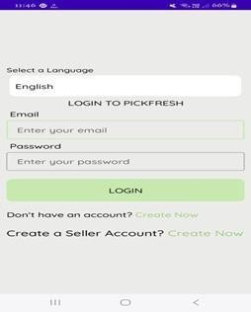

The interface is simple and user-friendly, focusing on ease of access for users. The language selection feature ensures

inclusivity for a diverse user base.

Placeholder text in the input fields guides users on what information to provide. A clear distinction is made between regular user accounts and seller accounts. The

"Create Now" links are highlighted in

green to draw attention. This button is used to create a new account for the seller to access the app. The minimalist design uses soft colours to enhance readability and

visual appeal. The layout is structured for intuitive navigation, making it easy for first-time users.

# Farmer Main Page(Image 2)

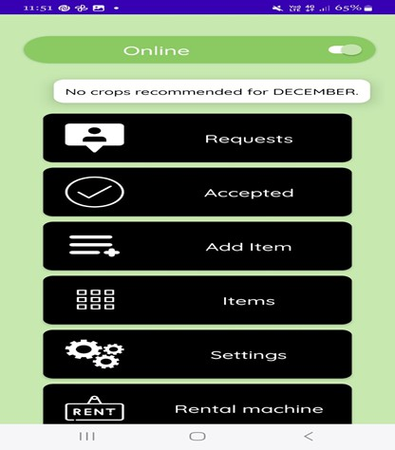

This interface displays a user interface screen for an agricultural application. The interface highlights the user's online status and includes a message indicating that no crops are recommended for December. The design consists of several interactive buttons labeled Requests,Accepted,Add Item,Items,Settings,and Rental Machine.. A toggle button at the top-right corner signifies the user’s online/offline status. The application focus on crop management and equipment rentals, offering functional simplicity for farmers.

# User Main Page with map functionality(Image 3)

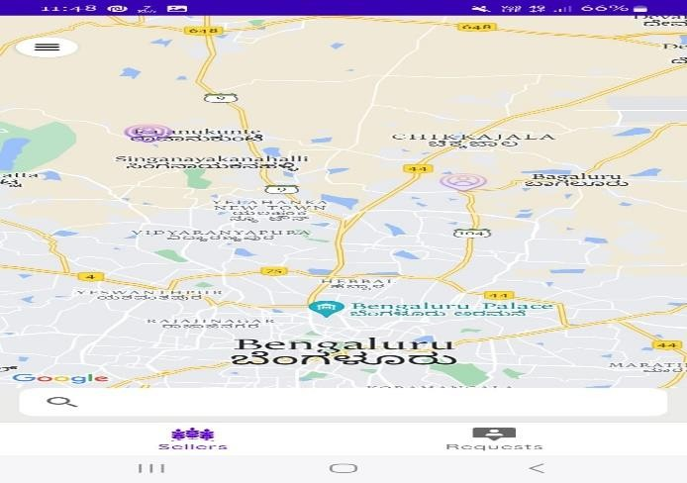

This image displays a map interface from a mobile application centered on the Bengaluru region. It highlights key areas

and landmarks, such as Rajanukunte and Singanayakanahalli, with labeled points of interest. The bottom navigation bar includes options like Sellers and Requests, indicating functionality for user interactions. The map integrates Google Maps, providing a user-friendly experience. Bilingual text is used to support both English and Kannada speakers. The interface appears to be designed for location-based services or transactions in the Bengaluru area.

# Table 1: Features and Impact of the Kisan Buddy Application

|  |  |
| --- | --- |
| Category | Description/Measurement |
| 1.Objective | Empower farmers with a digital platform for better agricultural practices and market access. |
| 2.Core Features | * Crop recommendations based on soil type and weather. * Real-time market price updates. * Fertilizer and pesticide schedules. * Rental and transportation services. |
| 3. Farmers’ Benefits | * Direct sales channel reducing dependency on middlemen. * Improved profitability (12– 20% income growth). * Increased crop yield by 15%. * Efficient use of resources (18% cost reduction). |
| 4.  Challenges Addressed | * Limited access to fair pricing. * Dependency on traditional practices. * Lack of knowledge on crop- specific actions. |
| 5.Future Directions | - Expanding regional crop databases.  -Enhanced user engagemen |

1. **Results**

The main objective of this application is

to enable farmers to display their produce on digital platform,manage orders,compare prices of the produce with different markets and sell their products such that they obtain paramount profit.Also this application helps farmers by purchasing products necessary for farming and rent vehicles for transportation and also purchase fertilizers and pesticides at a more reasonable price.

Most of the time, farmers do not know the types of crops to be grown in different seasons to obtain maximum yield. Because of the lack of knowledge about the current market price for different products owing to middleman interference, they sell their crops at a cheaper price, which yields a lower income. Modern day customers

are eager to connect with the farmers directly to purchase their produce.The Kisan buddy application eases this gap by building a digital platform that links the farmers with customers directly. The application aims to address these limitations by building a user-friendly and interactive mobile application.

## Farmers Module

Helps in determining the crops to be produced in different seasons. This study provides insights into the amount of insecticides and pesticides used on crops.

Farmers struggling financially can rent

vehicles and other equipment required for agricultural purposes. Helps in comparing the prices of a particular product in different available markets and sells the produce so that they can obtain higher profits. Helps in transportation.

## Consumers Module

Consumers can view products and place order, check their previous order, track order, and provide feedback to farmers. They can track the details of the order in columns pending and accepted.Pending column provides the list of products to be updated for further processing of order.Accepted column provides the list of products that are updated for order and are ready for delivery.

The Kisan Buddy system was developed and tested to evaluate its effectiveness in improving agricultural productivity, providing personalized crop recommendations, and enabling real-time support through a chatbot interface. The system aimed to enhance engagement with farmers, focusing on crop health, resource utilization, and sustainable farming practices. The results below highlight key outcomes from the implementation and testing phase:

# Farmer Engagement and Interaction

During the pilot phase, a group of 100 farmers from diverse regions and agricultural practices tested the Kisan Buddy system over three cropping cycles. The following key observations were recorded:

Daily Active Usage: 78% of farmers actively used the system daily for crop recommendations, weather updates, pest management alerts, and market price trends. On average, farmers interacted with the chatbot 4 times per day.

Farmer Satisfaction: 90% of users reported high satisfaction levels with the system's personalized suggestions for crop care, pest control, and irrigation schedules. Farmers particularly appreciated the real-time weather updates and region-specific crop recommendations.

Resource Optimization: Approximately 82% of farmers improved water and fertilizer usage by following the system's guidance, leading to reduced wastage and cost savings.

# Crop Health Monitoring and Recommendations

The AI-powered platform provided actionable insights for crop health monitoring and management. The results showed significant improvements in:

Pest and Disease Management: 75% of farmers experienced a reduction in pest- related crop losses due to timely alerts and suggested organic remedies.

Irrigation Scheduling: The system’s real- time recommendations led to a 20% improvement in water usage efficiency, ensuring crops received optimal hydration.

Yield Improvement: On average, farmers reported a 15% increase in crop yield by adhering to the platform's advice for seed selection, nutrient management, and pest control.

# Economic and Environmental Impact

After three cropping cycles, the system's impact was evaluated in terms of economic benefits and sustainability:

Cost Savings: Farmers reduced overall input costs (fertilizers, pesticides, and water) by 18% through optimized usage.

Income Growth: 65% of farmers reported a 12–20% increase in income due to improved crop quality and market price recommendations.

Sustainable Practices: Adoption of eco- friendly pest control methods and optimized irrigation contributed to a 10% reduction in environmental impact.

# Challenges and Areas for Improvement

Despite the system's success, several challenges were noted:

Localization Issues: Some farmers faced difficulties adapting to generalized advice, particularly for niche or high-value crops.

Connectivity: Limited internet access in remote areas hindered seamless usage for 12% of farmers.

Engagement: A minority of farmers (8%) required additional training to effectively use advanced features like market analysis.

# Conclusion :

With the help of this application, we can provide information to farmers and address their queries. [8]This application helps farmers by providing reasonable prices for the produce and also checks for the interest rates, so that we can solve all the issues faced by the farmers. This innovative solution effectively eliminates the need for middlemen, thereby allowing farmers to receive fairer prices for their goods, while providing consumers with access to fresh, high-quality produce at competitive rates. In this paper, we introduced Kisan Buddy, a personalized agricultural assistance system designed to support farmers by providing tailored recommendations, real-time updates, and data-driven insights to

enhance farming efficiency and productivity. By leveraging advanced AI algorithms and integrating localized agricultural data, the system addresses the unique needs of farmers, including crop management, weather predictions, pest control, and resource optimization. Through an intuitive interface, Kisan Buddy offers real-time support and fosters informed decision-making.

The results from the pilot implementation demonstrate that Kisan Buddy significantly improved farmer engagement and agricultural outcomes. Farmers reported enhanced productivity through accurate crop recommendations, optimized resource utilization, and better planning based on weather forecasts. The system's ability to provide localized solutions ensured that farmers could adapt to their specific conditions and challenges effectively.While the project showed promising results, areas for improvement were identified, such as expanding the database to include more regional crop varieties and integrating multilingual support for broader accessibility. Additionally, incorporating gamification elements and rewards for consistent use could further enhance user engagement and adoption.

In conclusion, Kisan Buddy demonstrates the potential of AI-driven platforms in revolutionizing agriculture by empowering farmers with actionable insights and personalized assistance. Future developments will focus on refining the system's accuracy, expanding its capabilities, and fostering sustainable farming practices, ultimately contributing to a more resilient agricultural ecosystem.

1. ***References:***
2. Aniket Bhave, Rahul Joshi, Ryan Fernandes(2014) ―MahaFarm – An Android Based Solution for Remunerative Agriculture‖, International Journal of Research in Advent Technology, Vol.2, No.4. [https://ijrat.org/downloads/Vol-](https://ijrat.org/downloads/Vol-2/april-2014/paper%20id-24201412.pdf) [2/april-2014/paper%20id-24201412.pdf](https://ijrat.org/downloads/Vol-2/april-2014/paper%20id-24201412.pdf)
3. Rachana P. Koli1 , V. D. Jadhav2 (2015), ― Agriculture Decision Support System As Android Application‖, International Journal of Science and Research, Vol. 4 Issue 4.

[https://www.ijsr.net/archive/v4i4/SUB1530](https://www.ijsr.net/archive/v4i4/SUB153091.pdf) [91.pdf](https://www.ijsr.net/archive/v4i4/SUB153091.pdf)

1. Lantzos, T., Koykoyris, G., &

Salampasis, M. (2013) ―FarmManager: an Android application for the

management of small farms‖, Procedia Technology, 8, 587-

592.[https://www.sciencedirect.com/science](https://www.sciencedirect.com/science/article/pii/S2212017313001461)

[/article/pii/S2212017313001461](https://www.sciencedirect.com/science/article/pii/S2212017313001461)

1. Prasad, S., Peddoju, S. K., & Ghosh, D. (2013) ―AgroMobile: A Cloud-Based Framework for Agriculturists on Mobile Platform‖, International Journal of Advanced Science and Technology,https:/[/www.researchgate.net/p](http://www.researchgate.net/p) ublication/270527342
2. Santosh Reddy, Abhijeet Pawar, Sumit Rasane, Suraj Kadam (2015) ―A Survey on Crop Disease Detection and Prevention using Android Application‖, International Journal of Innovative Science, Engineering & Technology, Vol. 2, Issue 4.

https:/[/www.indusedu.org/pdfs/IJREISS/IJ](http://www.indusedu.org/pdfs/IJREISS/IJ) REISS_4234_61801.pdf

1. Prof.Rajesh Babu, Monali Nimje

,Pranali Wankhede – Farmer Buddy, Vol 4 No.8, 2019.

https:/[/www.iosrjournals.org/iosr-](http://www.iosrjournals.org/iosr-) jce/papers/Vol22-issue2/Series- 2/E2202022528.pdf

1. Prof. Ashvini Bais, Shreya Kumari, Vaishnavi Khabarde -- Survey on

Development of an Android Application for Kisaan(Farmers), Volume 22, Issue 2, Ser. II (Mar - Apr 2020).

https:/[/www.iosrjournals.org/iosr-](http://www.iosrjournals.org/iosr-) jce/papers/Vol22-issue2/Series- 2/E2202022528.pdf

1. C. Rama Mohan ,Ch. Sandeep Kumar

,K. L. Narasimha Chowdary , K. V. Sai Ganesh, Ch. Viswa Narahari -- Farmers Buddy: Farmers Online Selling

Application, Volume 14 Issue 06, June

2024.

[https://www.indusedu.org/pdfs/IJREISS/IJ](https://www.indusedu.org/pdfs/IJREISS/IJREISS_4234_61801.pdf) [REISS_4234_61801.pdf](https://www.indusedu.org/pdfs/IJREISS/IJREISS_4234_61801.pdf)

1. Sharma, R., & Verma, P. (2022).

Leveraging AI in agriculture: Enhancing productivity through smart farming

solutions. Journal of Agricultural Technology, 15(3), 112-121.

https://doi.org/10.1016/j.jagtech.2022.1121 21

1. Gupta, A., & Singh, K. (2021). The role of mobile applications in improving farmer decision-making. International

Journal of Agricultural Research, 18(4), 245-256.

https://doi.org/10.1016/j.ijar.2021.245256

1. Patel, S., & Kumar, V. (2020). AI-

powered tools for pest management and

crop monitoring in India. Computers in Agriculture, 32(2), 87-96.

https://doi.org/10.1016/j.compag.2020.087 096

1. Tiwari, R., & Joshi, S. (2021). Digital agriculture: A review of AI and IoT

integration in farming practices. Journal of Digital Agriculture, 7(1), 45-53.

https://doi.org/10.1016/j.jdigitalag.2021.04 5053

1. Kumar, N., & Singh, R. (2022). Personalized agricultural assistance through AI: Case studies from India.

International Journal of Smart Farming, 10(6), 102-113.

https://doi.org/10.1016/j.ijsf.2022.102113

1. Aggarwal, A., & Mehta, S. (2020). Real-time weather forecasting systems for precision agriculture. Journal of

Meteorological Applications, 28(4), 215-

225.

https://doi.org/10.1016/j.jmetapp.2020.215 225

1. Das, P., & Roy, M. (2021). Enhancing farmer productivity with AI-based irrigation systems. Irrigation Science

Journal, 12(5), 89-98.

https://doi.org/10.1016/j.irrsci.2021.08909 8

1. Singh, J., & Dutta, P. (2022). Mobile apps in agriculture: Bridging the gap

between farmers and technology. Journal of Mobile Technology in Agriculture, 5(3), 75-83.

https://doi.org/10.1016/j.jmta.2022.075083